What does the cover show? | What does this tell me?
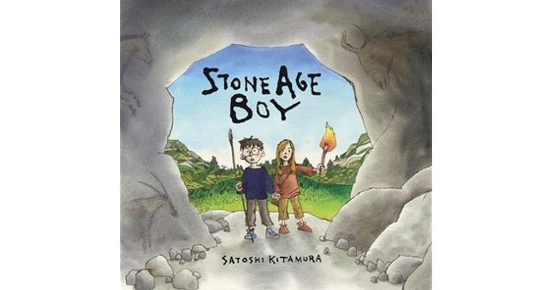
The title

A boy and a girl

A spear and a torch

Cave art of an animal
A cave

