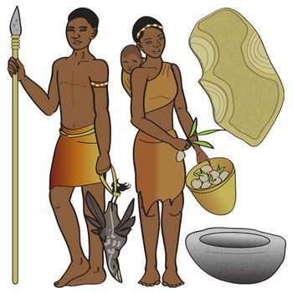
W.C 10th January 2022.
Can you write a diary entry about your day as a hunter-gatherer.
Remember when writing in a diary you will be using words like ‘I’ and ‘we’.
Top tip: Remember to use adjectives to make your writing more interesting!

Capital letters &  Full Stops  A • | Connectives   | WOW  words | Careful  spelling  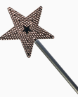 | 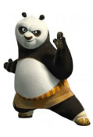  Kung fu punctuation | My writing makes sense.

____________________________________________________________________________________________________________________________________________________________________________________________________________________________________________________________________________________________________________________________________________________________________________________________________________________________________________________________________________________________________________________________________________________________________________________________________________________________________________________________________________________________________________________________________________________________________________________________________________________________________________________________________________________________________________________________________________________________________________________________________________________________________________________________________________________________________________________________________________________________________________________

