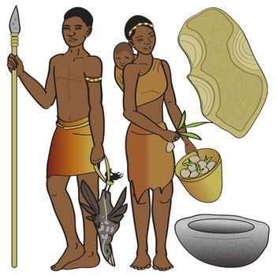
W.C 10th January 2022.
Can you write a diary entry about your day as a hunter-gatherer.
Remember when writing in a diary you will be using words like ‘I’ and ‘we’.

W.C 10th January 2022.
Can you write a diary entry about your day as a hunter-gatherer.
Remember when writing in a diary you will be using words like ‘I’ and ‘we’.

W.C 10th January 2022.
Can you write a diary entry about your day as a hunter-gatherer.
Remember when writing in a diary you will be using words like ‘I’ and ‘we’.

