

Allergy Safety Policy
The Diamond Learning Partnership Trust

Approved by: | Chief Executive Officer | Date: 2026
Last reviewed on: | September 2026
Next review due by: | September 2027

Contents

1. Aims 3
2. Legislation and guidance 3
3. Definitions 3
4. Allergy Safety 3
Introduction 3
Roles and responsibilities 4
5. Policy In Detail 5
Individual Healthcare Plans for allergy 5
Supply, storage, care, administration and disposal of medication 5
Spare Adrenaline Auto-Injectors 6
Spare asthma inhaler 7
School trips and visits 7
Food provision 7
Supporting adults with allergies 8
Serious incidents and near misses 8
Policy awareness, distribution and review 9
Appendices 10
Appendix 1 10
Appendix 2 11
Appendix 3 13
Links with other policies 15

1. Aims
The aim of our Allergy Safety Policy is to set out a clear and consistent approach to supporting pupils with allergies across The Diamond Learning Partnership Trust. This policy explains how our academies will identify pupils with allergies, assess and manage risk, ensure staff are appropriately trained, maintain access to emergency medication, and work in partnership with parents, carers, pupils and healthcare professionals. It is intended to help ensure that pupils with allergies are safe, well supported and able to participate as fully as possible in school life, while promoting awareness, inclusion and a prompt, effective response to allergic reactions and anaphylaxis.

2. Legislation and guidance
This policy has been written with reference to the national statutory and non-statutory guidance relevant to allergy safety, medical conditions and food provision in schools. In particular, it should be read alongside:
- Allergy safety in schools: statutory guidance – Department for Education statutory guidance setting out what schools must do to support pupils with allergies, including allergy safety policies, staff training, Individual Healthcare Plans, spare adrenaline auto-injectors, and recording and learning from serious incidents and near misses.
- Supporting pupils at school with medical conditions: statutory guidance – Department for Education guidance issued under section 100 of the Children and Families Act 2014, which explains the duty on schools and academies to make arrangements to support pupils with medical conditions.
- Using emergency adrenaline auto-injectors in schools – Department of Health and Social Care guidance on the purchase, storage and emergency use of spare adrenaline auto-injectors in schools.
- Emergency asthma inhalers for use in schools – Department of Health and Social Care guidance on the use of emergency salbutamol inhalers in schools.
- Allergy guidance for schools – Department for Education guidance on managing allergy risks in relation to school food, menu changes, allergen information and special dietary needs.
- School food standards: resources for schools – Department for Education resources supporting compliance with the school food standards and the provision of healthy food in schools.

3. Definitions
N/A

4. Allergy Safety

Introduction

Allergy is a medical condition in which the body’s immune system has an abnormal reaction to normally harmless substances such as food, insect stings, contact allergens and airborne allergens. The reaction can cause minor symptoms such as itching, sneezing or rashes but sometimes causes a much more serious reaction called anaphylaxis.

Anaphylaxis is a serious, life-threatening allergic reaction, affecting the person’s airway, breathing and circulation (often referred to as the ABC symptoms). The whole body is affected often within minutes of exposure to the allergen, but sometimes it can be hours later. Many individuals with allergies to food or insect stings are at risk of anaphylaxis.

It is possible to be allergic to anything which contains a protein; however, most people will react to a fairly small group of potent allergens. Common UK allergens include (but are not limited to):

- Peanuts
- Tree Nuts
- Sesame
- Milk
- Egg
- Fish
- Lupin
- Sulphur Dioxide
- Gluten
- Celery
- Crustaceans
- Molluscs
- Mustard
- Soybean
- Latex
- Insect venom
- Pollen
- Animal Dander

This policy sets out how our academy will support pupils with allergies, to ensure they are safe and supported to participate as fully as possible in school life. We are committed to ensuring that all children with allergies are properly supported in school so that they can play a full and active role in school life, remain physically and mentally healthy and achieve their academic potential. Academy staff will be alert to the risks of social isolation and exclusion for pupils with allergies, and will act proactively to provide support and reassurance. Any incident of poor behaviour or bullying relating to an allergy will be responded to in line with the academy’s behaviour and anti-bullying policies.

Roles and responsibilities

Parents
- Parents are required to inform school staff when enrolling their child at the school of any diagnosed allergies, including all previous serious allergic reactions, history of anaphylaxis and details of all prescribed medication.
- Parents are requested to supply a copy of any relevant documentation from healthcare professionals related to management of the allergy.
- Parents are responsible for ensuring any required medication is supplied, in date and replaced as necessary.
- Parents are requested to keep the school up to date with any changes in the allergic condition and/or its management.

Leadership team
- The named leader from our academy Senior Leadership Team with responsibility for allergy safety, including the implementation of this policy, is Suzi Whiting, Executive Headteacher. Individual tasks and responsibilities as outlined in this policy may be delegated to other staff, but responsibility for safe and effective practice remains with the named leader.
- The named leader will ensure that all staff employed directly by the school complete suitable allergy awareness and emergency response training. Please see annex 1 for further details of the minimum mandatory content for this training. This will take place upon induction and updated annually.
- The named leader will complete an assessment of further training needs in order to support the requirements of a pupil’s Individual Healthcare Plan, and allocate additional training to named staff as required.
- The named leader will liaise with office staff and other school or Trust leaders to ensure that contracted staff and/or agency staff who are working on site in a pupil-facing role have completed suitable allergy awareness and emergency response training, in line with the minimum mandatory training content.
- The named leader will implement an effective system for collecting and recording information from parents about any known allergies, and liaising with any previous settings for relevant information, as required.
- The named leader will ensure that an Individual Healthcare Plan for allergy (see annex 2) is completed for any pupil with an allergy which has a functional impact on them in school, they are at risk of harm as a result of their allergy and they require arrangements which are additional to or different from those made generally.
- The named leader will implement an effective system for informing all staff, including those who are contracted and/or agency staff, which children have an allergy requiring an Individual Healthcare Plan, how to access their information, and where their medication is located (if relevant).
- The named leader will work together with school staff to identify any school-based activity or event that may pose a risk, or increased risk, to pupils with allergy, and implement suitable measures to safely manage this risk so that the pupil remains included.
- The named leader will implement an effective system for ensuring pupils who are prescribed emergency medication have rapid access to this at all times, including activities before and after school, and those taking place outside of school, i.e. trips.
- The named leader will implement an effective system for checking medication kept at school on a regular basis and alerting parents if medication is approaching expiry, in line with the policy for Supporting Medical Conditions and Administration of Medication.

Staff
- All staff will complete allergy awareness and emergency response training upon induction, updated annually, which will be delivered via the Trust’s online learning platform, National College.
- Named staff will complete additional training in order to support the requirements of a pupil’s Individual Healthcare Plan for allergy.
- All staff will be aware that an allergic reaction could occur at any time, so will be aware of all pupils in school who have known allergies, and will review relevant information so that they are informed about managing their condition.
- All staff will be aware of any school-based activities involving exposure to known allergens, including during social times, i.e. lunch, and will work with the named leader to take appropriate steps to minimise risk and supervise closely.
- All staff leading school trips will ensure that relevant staff carry all prescribed medication for all pupils with allergies, i.e. Adrenaline Auto-Injector.
- All staff will respond to any signs of allergic reaction, including anaphylaxis, in line with procedures outlined in the pupil’s Individual Healthcare Plan for allergy, or if the allergy was not previously known, in line with emergency guidance outlined in annex 3.
- All staff will record administration of medication in line with the policy for Administration of Medication.

Pupils
- All pupils are expected to follow academy rules relating to safety for themselves and others.
- Pupils with known allergies are encouraged to have a good awareness of their symptoms and to let an adult know as soon as they suspect they are having an allergic reaction.

5. Policy In Detail

Individual Healthcare Plans for allergy

An Individual Healthcare Plan for allergy will be completed for any pupil for whom an allergy has a functional impact on them in school, they are at risk of harm as a result of their allergy, and they require arrangements which are additional to or different from those made generally. We follow the suggested template provided by the Department for Education in their statutory allergy safety guidance, please see annex 2.

The Individual Healthcare Plan for allergy will be completed in collaboration with parents and informed by advice from healthcare professionals where necessary. We recognise that co-production with parents, and with pupils at an age-appropriate level, gives the strongest reassurance for robust allergy management as well as helping us to understand how the allergy can impact the pupil’s health, education and wellbeing. In the event that a new pupil had an Individual Healthcare Plan for allergy at a previous setting, a new document will be completed, informed by any information sought and received from the previous setting.

The Individual Healthcare Plan for allergy will confirm information about any prescribed medication to help manage the allergy, including what was prescribed, by whom and when, whether and when parental consent has been received for the medication to be administered, and where the medication is stored. Any care plan or action plan provided by a healthcare professional will be held alongside the Individual Healthcare Plan for allergy. Agreements about flexible management or reasonable adjustment will also be recorded.

Upon completion, the Individual Healthcare Plan for allergy will be uploaded onto Medical Tracker and alerted to all staff.

All Individual Healthcare Plans for allergy will be reviewed at least annually, and more frequently if the pupil’s needs have changed or in the event of a serious incident or near miss.
Where an allergy is suspected but not yet diagnosed, we will put suitable arrangements in place to support the pupil, in line with advice from healthcare professionals.

Supply, storage, care, administration and disposal of medication

Due to the age of our pupils, academy staff will take responsibility for all medication required by pupils for allergy management as stated on their Individual Healthcare Plan for allergy. Medication provided by parents to be used and stored at school must adhere with the academy’s policy for administration of medication, including being in date and provided in the original pharmacy container. In line with statutory guidance, parents of pupils who have been prescribed Adrenaline Auto-Injectors will be asked to provide two such devices to be stored at school.

All allergy medication will be stored safely in a location accessible to all staff and, if required, will be moved by staff throughout the school building alongside the pupil to ensure quick access. This will take into account guidance stating that, in a case of anaphylaxis, adrenaline should be administered within five minutes. Any medical guidance issued to ensure safe storage and effectiveness of the medication, i.e. avoiding direct sunlight, will be heeded. Allergy medication will be in a suitable container and clearly labelled with the pupil’s name, stored alongside a copy of their Individual Healthcare Plan for allergy and any additional, relevant documentation, i.e. allergy action plan. We will discuss with parents suitable arrangements for ensuring the pupil’s access to any medication for managing their allergy during their journey to and from school.

Medication will be administered and overseen by staff, in line with the academy’s policy for administration of medication, and recorded accordingly.

Parents are responsible for ensuring that their child’s medication is up to date. In addition, we will regularly review medication kept at school and send a reminder to parents if medication is approaching expiry.

Expired and single-use medication will be disposed of in line with our policy for administration of medicines. Used Adrenaline Auto Injectors will be disposed of as sharps, in line with health and safety guidance.

Spare Adrenaline Auto-Injectors

We are aware of the unpredictable nature of anaphylaxis reactions, and that up to 20% of anaphylaxis reactions in schools happen in children without a pre-existing diagnosis of allergy. We have purchased spare Adrenaline Auto-Injectors for emergency use by anyone experiencing anaphylaxis who has not previously been prescribed medication, or anyone who does not have sufficient dosage of their own medication. Number and dosage of devices is in line with DfE guidance as outlined in the table below.

AAIs for children under age 6 years (150 micrograms) e.g. EpiPen Junior, Jext 150 | AAIs for anyone over 6 years of age (300 micrograms) e.g. EpiPen, Jext 300
One | One

Spare Adrenaline Auto-Injectors are stored in the staff room in a clearly labelled container stating ‘EMERGENCY ANAPHYLAXIS KIT’ alongside instructions for their use. This location will be known and communicated to all staff and devices will remain accessible at all times. Each pair of spare Adrenaline Auto-Injectors will be stored together so that if a second dosage is needed it is immediately available.

In the event that anaphylaxis is suspected in anyone with or without a prior diagnosis, we will follow emergency procedures to contact emergency services and administer adrenaline as required. While there is a not a legal requirement to gain parental consent prior to administration, we will use Auto-Injectors in order to save life and avoid delays in treatment.

Care, review and disposal of spare Adrenaline Auto-Injectors will be managed as outlined above. Replacement of spare Adrenaline Auto-Injectors will be arranged in line with expiry dates so that there is no delay in having in-date devices on site.

Spare asthma inhaler

It is recognised that asthma is the most common long-term condition among children, and that a significant number of children at risk of anaphylaxis due to allergy are also diagnosed with asthma. In line with Department of Health guidance for use of emergency salbutamol inhalers in schools, we have a spare asthma reliever inhaler for use in emergencies if a pupil’s prescribed inhaler is not available. Our spare asthma reliever inhaler will be stored alongside our spare Adrenaline Auto-Injectors in the staff room. in a separate, clearly labelled container stating ‘EMERGENCY ANAPHYLAXIS KIT’ alongside instructions for its use. This location will be known and communicated to all staff and the inhaler will remain accessible at all times. We may use our spare asthma inhaler in order to save life and avoid delays in treatment.

School trips and visits

In addition to enabling participation as fully as possible with school-based activities, we will take all reasonable steps to support pupils with allergies to participate as fully as possible in school trips and visits taking place outside of school. Where necessary, we will engage with parents to share details of the trip or visit in advance and discuss any concerns. All academy staff accompanying a school trip or visit will have completed allergy awareness and emergency response training, as outlined above. All planned activities taking place on a trip or visit will be risk assessed to gauge the presence of any threat to pupils with allergies, and suitable alternative activities will be planned to ensure their inclusion, if required.
Staff leading a school trip or visit will ensure all medication stored at school for children with an Individual Healthcare Plan for allergy is taken from school to the trip or visit, alongside a copy of their Individual Healthcare Plan for allergy and any additional, relevant documentation, i.e. allergy action plan. Medication will be carried by a staff member who is in close proximity to the child throughout the entirety of the trip or visit, including during any journeys to and from the academy. Our risk assessment will consider whether any spare Adrenaline Auto-Injectors should be taken on the trip or visit. This cannot cause a shortage of spare devices on the academy site.

In the event that the trip or visit involves food being provided externally, i.e. residential accommodation, their staff will be informed in advance by academy staff that a pupil with food-based allergies will be in attendance and guide them on the nature and requirements of their condition. If the external provider feels unable to safely cater for the pupil’s condition, we will make alternative arrangements.

Food provision

The Requirements for School Food Regulations 2014 (known as ‘The School Food Standards’) regulates any food and drink provided by the academy to pupils at breakfast, lunchtime and across the school day, with which the academy and our providers will be strictly compliant. This includes the need to provide information about the 14 regulated allergens present in the food that is served. We will make necessary adjustments to cater for pupils with food allergies or intolerances, and to identify, minimise and manage risk effectively to allow all pupils to be fully included in meals. This includes any pupils entitled to Free School Meals.

School menus are changed twice a year, in September and after February Half Term. Menus are finalised and published 1 month before going live. In line with the schools set menu, a dairy free and gluten free menu is also designed. Menus are published on each schools website and sent to parents/carers. Every dish on our menus has a recipe where all ingredients are clearly highlighted. Alternate products such as gluten free and dairy free items are used to cater for pupils with these dietary requirements.
Our named leader for allergy safety is responsible for ensuring that all staff, including catering staff, whether employed by school or contracted/agency, are aware of pupils with food allergies and the nature of their condition, and that this information is regularly updated. In line with statutory guidance, two robust methods are in place to identify pupils with known allergy at mealtimes to ensure they receive a safe meal. Photographs of pupils alongside details of their allergy are displayed in the serving area, as well as coloured wristbands to identify pupils' meal choice. Pupils with food allergies will not be segregated and will be able to enjoy school meals alongside their peers, with any risks managed effectively. If menus need to be adapted at short notice, the needs and safety of pupils with food allergies and intolerances, and statutory allergen requirements, must still be met, and changes will be highlighted.

We will communicate with parents to explain our expectations for food brought into the academy, i.e. in lunchboxes, and to raise awareness of the risk of food allergens. In line with any known food allergens for our pupils, we may choose to discourage certain food items, i.e. nuts. However, we know that no guarantee can be made that a truly allergen free environment can be achieved, i.e. a ‘nut free school’, so discouragement of certain allergens will not be a substitute for sharing general information regarding allergy awareness of all relevant foods.
We will actively engage with parents of pupils with food allergies to make suitable arrangements in their Individual Healthcare Plan for allergy to safely manage food brought on site either by the pupil, their peers, staff or any visitors. This will reflect Department of Health guidance, including such measures as labelling food containers and drinks bottles for the food-allergic pupil, informing pupils about the risks of sharing food, utensils and containers, and additional consideration and risk assessment for use of food in curriculum activities or school events, i.e. cooking, community events.

Supporting adults with allergies

Any adult working on site or visiting the academy with a diagnosed allergy is requested to inform office staff upon arrival. The named leader for allergy safety is responsible for ensuring suitable arrangements are implemented to support with managing the condition, including requesting information from the individual regarding any medication they carry. If food is being served, adults working on site or visiting the academy will be explicitly asked if they have a food allergy or intolerance. The measure outlined above for access to spare Adrenaline Auto-Injectors also apply to adults.

Serious incidents and near misses

We recognise that we can never remove the risk of an incident linked to an allergy. All staff will be encouraged to be self-reflective about the academy’s arrangements and seek to improve them wherever possible.

In the context of this policy, a serious incident is defined as someone with an allergy who is harmed or is placed at an immediate and significant risk of harm, including situations requiring emergency medication, urgent clinical intervention or attendance by emergency services.
A near miss is defined as an event relating directly to an allergy that did not result in harm but had the clear potential to do so, for example, where an error, omission, or system failure could reasonably have led to a serious incident had circumstances been only slightly different. Parents will be informed of a serious incident or near miss as soon possible.

Subsequent to any serious incident or near miss, a record of events will be made on Medical Tracker, including who was affected, what happened, when and where, why the incident occurred, as far as is known, how staff and pupils responded, what was done to support the individual, whether emergency services were called and how the incident concluded, as well as any learning that has been identified and follow up actions that are being implemented. This report will be shared with parents and the named leader for allergy safety. We will work with the pupil, their peers, staff and parents to reflect constructively on what happened and provide additional support where needed. The pupil’s Individual Healthcare Plan for allergy will be updated as required.

In addition, we will adhere to all legal and statutory requirements as required by the Food Standards Agency and the Health and Safety Executive (HSE). The named leader for allergen safety will also share information related to a serious incident or near miss with healthcare professionals responsible for supporting management of the pupil’s condition, where relevant, and liaise with them to review arrangements to ensure they are robust and appropriate.

In the event that the incident indicates a pupil is at increased risk of being neglected, abused or exploited by an adult, whether within the family or within our academy, the Designated Safeguarding Lead will respond in line with our academy’s safeguarding policy.

Policy awareness, distribution and review

This policy will be published on our academy website, and is available in hard copy on request. It will be shared with all staff upon induction and following review, as outlined above.

Appropriate communications will be regularly shared with parents and pupils, at an age-appropriate level, to explain our approach to allergy safety and sharing specific, known allergy risks relevant to our academy if appropriate. This will be supported by posters and information displayed in the academy building.

This policy will be reviewed annually, or more frequently in the event of an incident or near miss where improvements can be suggested.

Appendices

Appendix 1

Mandatory content of allergy awareness and emergency response training – use this information to assess the suitability of training completed by staff, including those externally contracted or provided by an agency

Have an awareness of allergy, the risks it poses, how allergic reactions can occur and how to manage it
Understand that allergy includes multiple conditions (food allergy, asthma, eczema, hay fever, others), which can co-exist
Understand the difference between food allergy, coeliac disease and food intolerance
Know where to find information on allergy triggers
Can identify the range of symptoms of allergic reactions
Understand and can recognise anaphylaxis
Know how to respond in an emergency, including:
- calling emergency services and informing parents
- how to locate and administer emergency medication (adrenaline for anaphylaxis, asthma reliever inhaler for an asthma attack)
- training on how to use the medication/device in an emergency (whether prescribed to a given person or a school’s “spare” adrenaline devices)
Understand the impact allergy can have on a child or young person’s wellbeing
Understand the school, college or setting’s allergy safety policy
Know how to check whether an individual is on the record of those with known allergy and how to use an Allergy or Asthma Action Plan
Understand their responsibilities in reducing the risk of individuals with known allergy coming into contact with their known allergens
Understand how to report an allergic reaction or case of anaphylaxis (whether an incident or a “near miss”)

Appendix 2

NAME – Individual Healthcare Plan for allergy
Date of birth: |  | Current photo
Year / class: |  | Current photo
Emergency contacts: |  | Current photo
#1: | #2: | Current photo
Allergy:
Note what allergy the child or young person has.
Note any known allergens.
Note whether the child or young person is likely to be aware that they are having an allergic reaction and whether they can alert others.
How the allergy is managed:
Note any care or action plans or prescribed medication issued by healthcare professionals.
If the allergy can be partly or wholly managed by practical adjustments (for example avoidance of known allergens), note them here.
Note the extent to which the child or young person is able to take responsibility for managing their allergy.
Impact on education:
Indicate the potential harm which might come to the child or young person if their allergy is not managed properly.
Indicate how the allergy may impact on the child or young person’s learning.
Indicate how the allergy may impact on the child or young person’s emotional wellbeing.
If relevant, note any interaction between allergy and SEN.
Arrangements for support:
Give details of the specific support or adaptations which the school, college or early years setting will put in place, within its educational remit.
Outline measures to reduce the risk of contact with known allergens.
Give details of the specific support or adaptations to manage food allergy at meal and snack times.
Note arrangements for maintaining educational progress where absence or missed learning occurs due to allergy.
Visits and trips:
Give details of any arrangements or procedures which may be required for school trips or other activities outside of the normal timetable that will ensure the child can participate.
Note any requirement for a risk assessment and prompts for specific issues which should be considered.
Emergency response:
Where an Action Plan issued by a healthcare professional covers emergency response, refer to it and ensure it is attached.
Otherwise summarise the signs or symptoms which would indicate an emergency.
Set out what to do in an emergency, including whom to contact.
If relevant, note where “spare” adrenaline devices are located.
Last discussed with parents: |  | Date
Next planned review: |  | Date:

NAME – Individual Healthcare Plan for allergy - medication
Non-prescription medication:
Record any non-prescription medication (e.g. oral antihistamines) which the child or young person may require to manage their allergy in the education setting
Note whether it is emergency medication; where the medication is stored; and how and when the child or young person may need access
Parental consent: | Date:
Prescription medication:
Record any prescription medication for allergy prescribed by a healthcare professional (e.g. adrenaline).
Note whether it is emergency medication; where the medication is stored; and how and when the child or young person may need access.
Prescribed by: | Date:
Parental consent: | Date:
Use of “spare” adrenaline devices:
Note whether parental consent has been given to administer adrenaline (e.g. using “spare” adrenaline devices) in an emergency.
Parental consent: | Date:
Use of “spare” salbutamol inhaler:
If relevant (i.e. the child or young person is prescribed an asthma reliever inhaler), note whether consent has been given to use a “spare” salbutamol reliever inhaler.
Parental consent: | Date:

NAME – Individual Healthcare Plan for allergy - Care or Action Plans issued by healthcare professionals
Allergy / Asthma Action Plan:
Attach any Action Plan to the IHP for use in an emergency.
Note which healthcare professional issued the plan, their role and the date issued.
Issued by: | Date:
Care Plan:
Note where any relevant care plan can be found.
Note what staff are responsible for delivering / supporting delivery of the care plan.
Note which healthcare professional issued the plan, their role and the date issued.
Date: | Date:

Store this document and any accompanying documentation and alert all staff.
If medication has been prescribed, store a printed copy of this document and any accompanying documentation with the pupil’s medication alongside a copy of relevant allergy awareness and response information (see annex 3).

Appendix 3
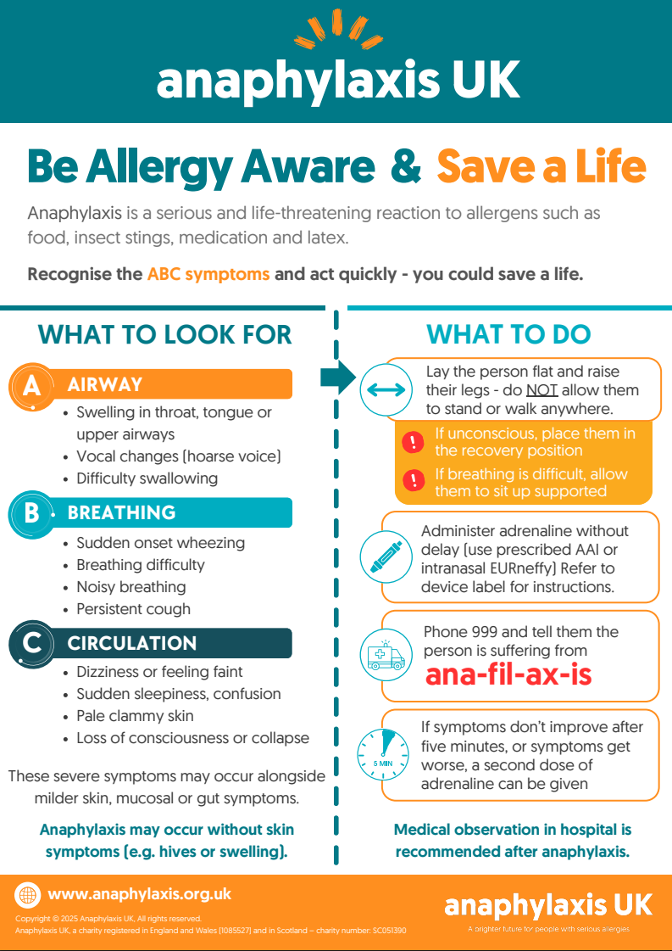
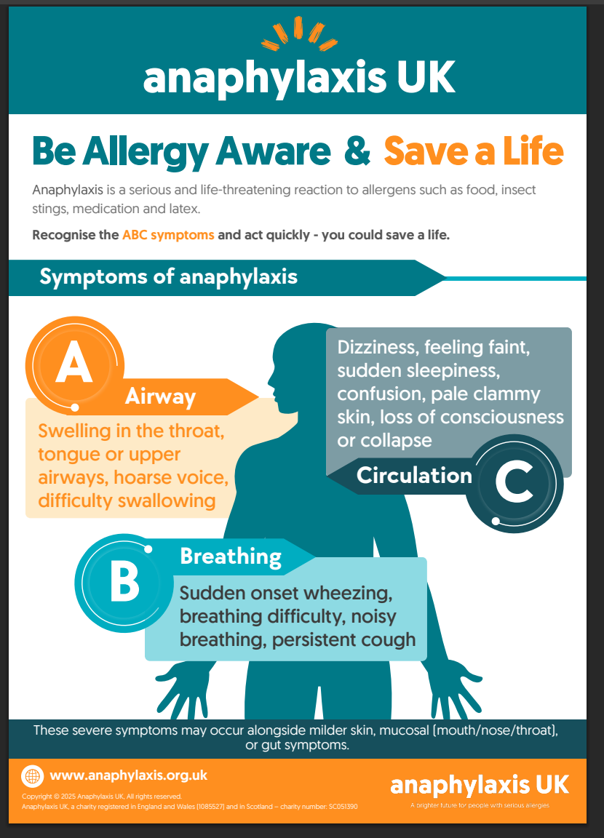
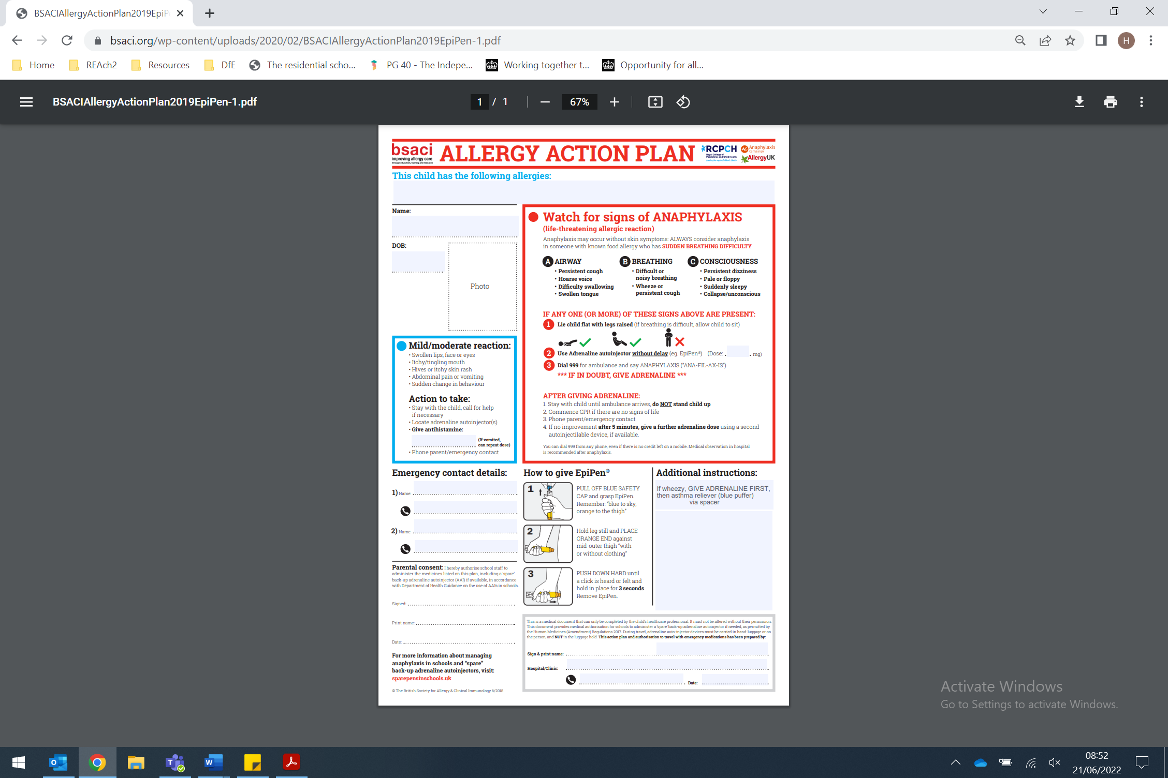

Appendix 4

Students Details
School/Academy |  |  |  |  |  | Male |  | Female
Student’s Name
Student’s Class
Diet required or allergy information (please tick) |  | Peanut | Milk |  | Crustacean |  | Soybean | Fish
Can may contain products be eaten? Yes / No |  | Celery | Nuts |  | Sesame Seeds |  | Mustard | Lupin
 |  | Eggs | Molluscs |  | Gluten |  | Sulphites | *Other
 |  | *Other – Please state
Please provide details of the nature of the allergy/intolerance
Has the allergy or intolerance been medically diagnosed? (Please provide evidence)
The Company uses a colour coding system to identify student requirements. Please tick which applies:
RED – student has had a severe reaction/anaphylactic shock
AMBER – student has an allergy or intolerance
BLUE – student excludes foods due to life style choice
For students that have been identified as RED a meeting must be arranged between the Company and Parents to discuss the student’s requirements and agreed actions. Without this meeting we are unable to cater for the student due to the risk.
Life Style – please provide details for dietary requirements based on lifestyle choices:
Parent/Guardian Details
Main contact name and relationship
Main contact – phone number and email address
Second contact – name and relationship
Second contact - phone number
Other Information
Has a photo ID form been completed and issued to the kitchen? |  |  |  | If EpiPen/ medicine is needed, who is the contact in school and is it kept on site?

Parent/Guardian Acceptance
Whilst we can provide meals which do not include allergens we cannot guarantee that dishes may contain traces of allergens, as these may be stored, prepared & cooked in the same kitchen. As well as present in some ingredients from our suppliers due to production techniques.
I confirm that the information supplied is correct and will notify of any changes to the school and caterer immediately. I also understand that this information will be shared with others and displayed in the kitchen (photo & allergy)
Name | Signed | Date

 | Agreed Actions
RED Category Student
Plated Meal provided
Packed lunch provided by the parent/guardian
Student going home
Other
AMBER & BLUE Student - Please list suitable foods
Any other relevant information
Operations/Area Manager |  | Signed | Date
Unit Manager Name |  | Signed | Date

Links with other policies
This policy links to our policies on:

