

Ancient Egyptians

Fun facts:
- Egyptian men and women wore makeup. It was thought to have healing powers, plus it helped protect their skin from the sun.
- They used mouldy bread to help with infections.
- They were one of the first civilizations to invent writing. They also used ink to write and paper called papyrus.
- The Ancient Egyptians were scientists and mathematicians. They had numerous inventions including ways to build buildings, medicine, cosmetics, the calendar, the plough for farming, musical instruments, and even toothpaste.
- The Pharaoh kept his hair covered. It was not to be seen by regular people.
- Cats were considered sacred in Ancient Egypt.
- The Ancient Egyptians are very famous for building the pyramids, amazing structures created as tombs for the rich and powerful. Incredibly, they have remained standing for thousands of years and can still be visited today!
- People in Ancient Egypt believed in the afterlife and practised Mummification, a process that preserved the body of the deceased.
- They wrote using hieroglyphics, and produced some of the world’s first examples of mathematical writing.

Learning Journey — We will be exploring

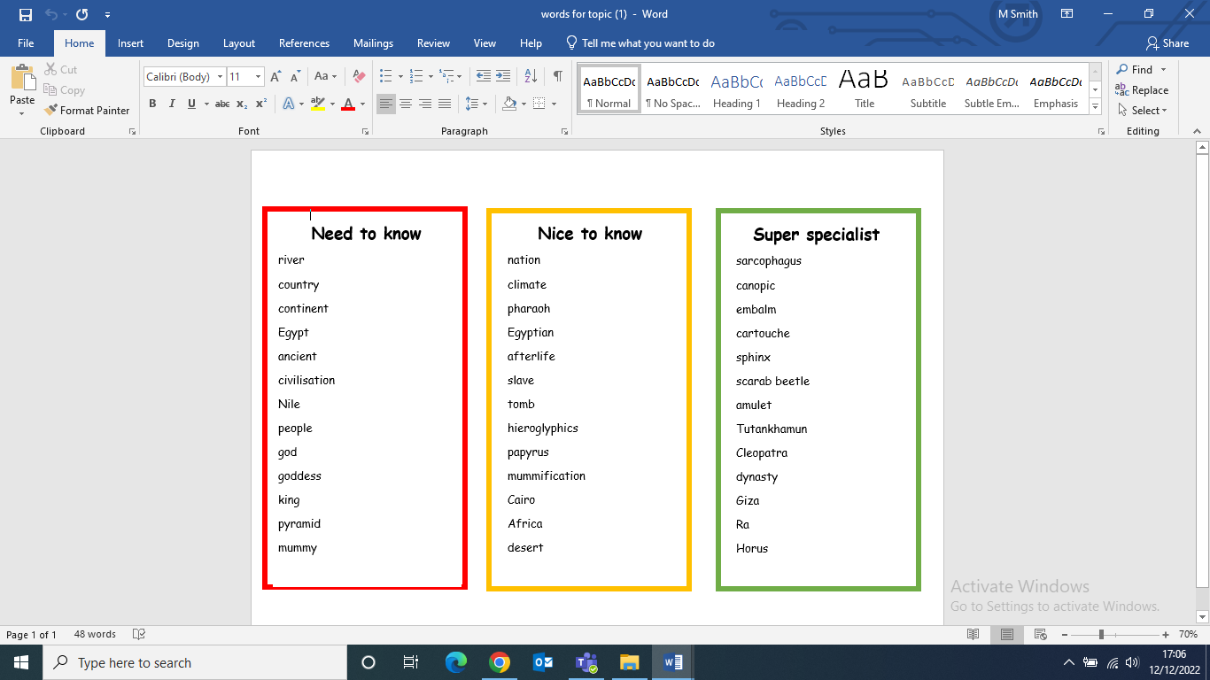

Links to Prior Learning | Key Texts | Links to Future Learning
- Gods and Goddesses for different areas of life e.g. wealth, poetry etc  - Viking and Anglo-Saxon runes  - Knowledge of past, present and future.  - Chronology skills and ordering events.  - Comparison skills.  - Ability to locate on a map. | - Flat Stanley - The Great Egyptian Grave Robbery by Jeff Brown  - Ancient Egypt: Tales of Gods and Pharaohs by Marcia Williams  - See inside Ancient Egypt by Rob Lloyd Jones  - The Egyptian Cinderella by Shirley Climo. | - Chronological awareness  - Comparison skills.  - Similarities and differences through human and physical geography.
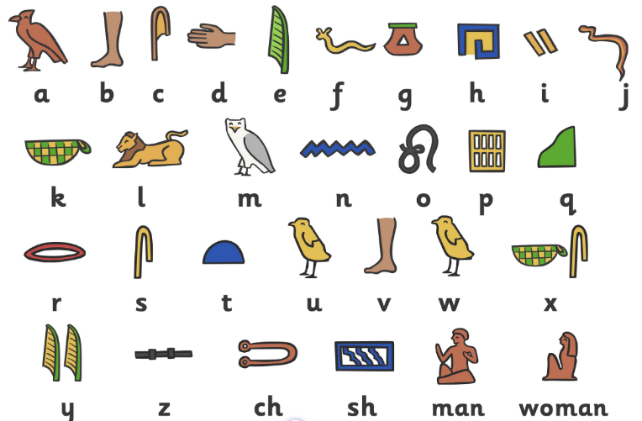
Family Fun
- Pay the British Museum in London a visit and explore their Egyptian collection.
- Design & make a piece of Egyptian jewellery.
- Research and create a family tree of an Egyptian Royal family. You could also create and present your own family tree.
- Write a list of 5 questions you would like to ask a person who lived in Ancient Egyptian times.
- Create an Ancient Egyptians Rosetta stone and write a message in hieroglyphics.
- Create a bar graph showing how long each of the Ancient Egyptians pharaohs reigned.
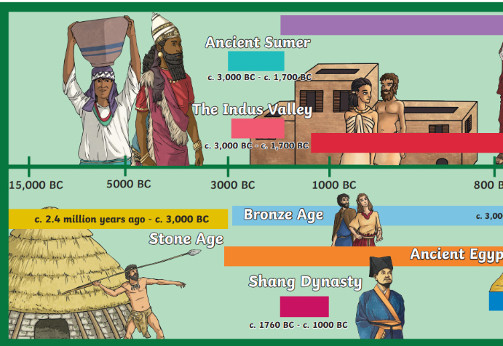
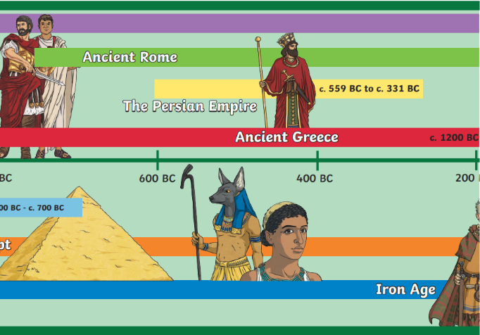
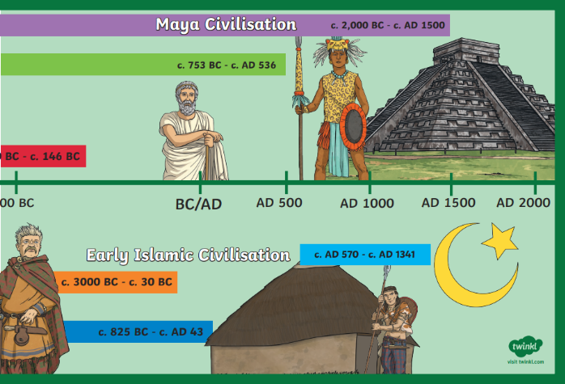
- Write a dairy of a day in the life of a slave or pharaoh. Make a 3D model of an Ancient Egyptians pyramid.

