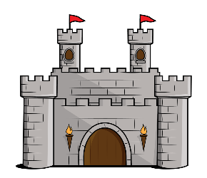
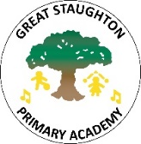
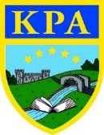
Castles

Learning Journey—
Through this history topic pupils will learn that England has been ruled by Kings and Queens for many years and will learn to sequence some key rulers. Pupils will use historical sources such as the Bayeux Tapestry to find our about key events in history such as the Battle of Hastings and will learning about significant turning points such as the signing of the Magna Carta by King John.
Pupils will develop historical enquiry skills and be asked to make inferences and explain their thinking. They will explore medieval artefacts, compare images and consider changes through time. The children will learn about the features of the first castles and why they were important for Norman invaders. They will find out about the people who lived in castles and the different jobs they had and how castles have changed through time.
Key facts:
- A castle is a strong building that was often the home of a king or lord in medieval times and afterward.
- Castles were built in many places, including Japan, India, and other countries.
- The leader’s fortress was often built on a high mound encircled by a ditch and topped with a stronghold.
- The current British monarch is King Charles III
- At the Battle of Hastings, William, duke of Normandy, defeated King Harold II to win the English throne. The battle took place on 14th October 1066.

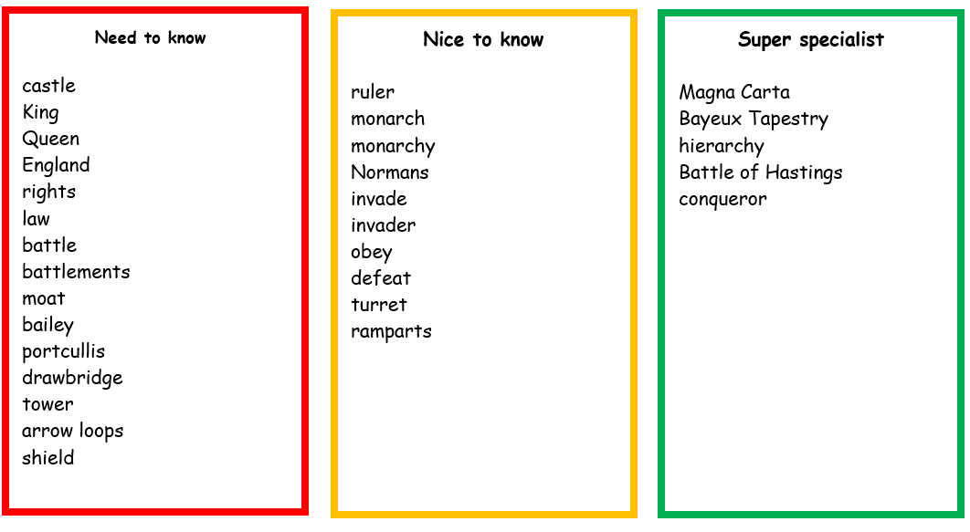

Magna Carta: was a document that gave certain rights to the English people. It stated that everyone, even the King must obey the law.
Bayeux Tapestry: an embroidered 70-meter-long cloth depicting the events leading up to the Battle of Hastings in 1066.

Links to Prior Learning | Key Texts | Links to Future Learning
- Children have prior knowledge of Great Britain and its current monarchy.  - Children also have prior knowledge of historical enquiry skills from previous history topics.  - Pupils have knowledge of British Values such as democracy, explored in PSHE.  - Making observations of the world around us and understanding of different cultures. (EYFS people and communities) | - The Castle the King Built by Rebecca Colby and Tom Froese  - George and the Dragon by Christopher Wormell  - Winnie and Wilbur: The Naughty Knight by Valerie Thomas and Korky Paul  - Attacking a Norman Castle by Robin Twiddy  - Look Inside a Castle by Conrad Mason and Barry Ablett | - Future topics taught in Year 3/4 like ‘The Roman Empire’  - Continents and countries  - Developing historical enquiry skills needed in KS2.
Family Fun
- Visit your local library or on online library to find out about castles. Can you draw a picture and label the features?
- Find out about castles and complete the quiz at: https://www.bbc.co.uk/bitesize/topics/zqbsydm/articles/zq8t6g8
- Watch an animated version of the Bayeux Tapestry here: https://youtu.be/LtGoBZ4D4_E
- Visit a castle! Eg Warwick Castle! Or watch a virtual tour here: https://youtu.be/wEp8gnA6p28
- Build your own castle using junk modelling or larger boxes! How will you make it strong? How will you defend your castle?

